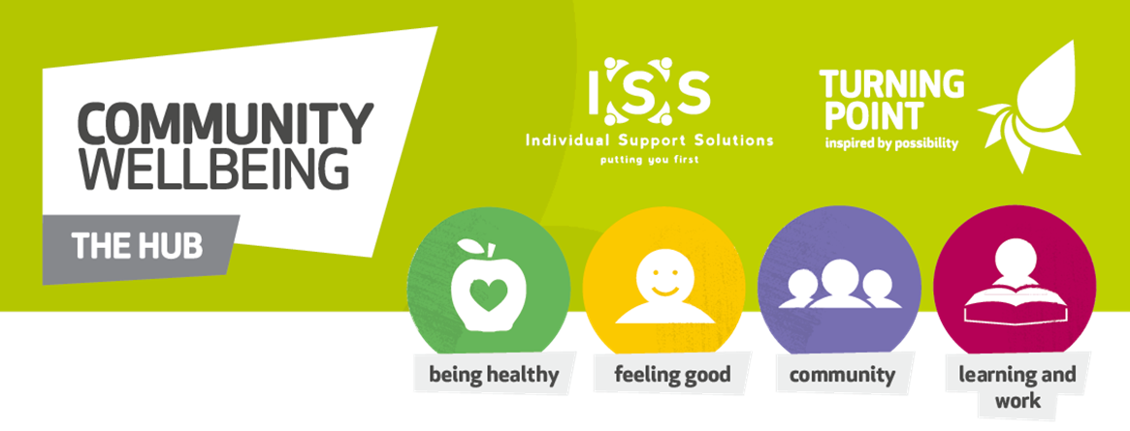

Relaxation is coming to
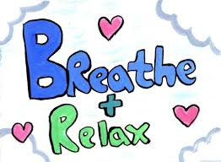
Rugby Hub
On Fridays
in September 2019
if you feel a little anxious or just want a little time out in your busy day-to-day life,
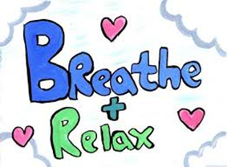
this is for you
It is a free session
and
will be held at Rccg House after Seated Exercise
To book your place please contact Yvonne on 07936 015966

