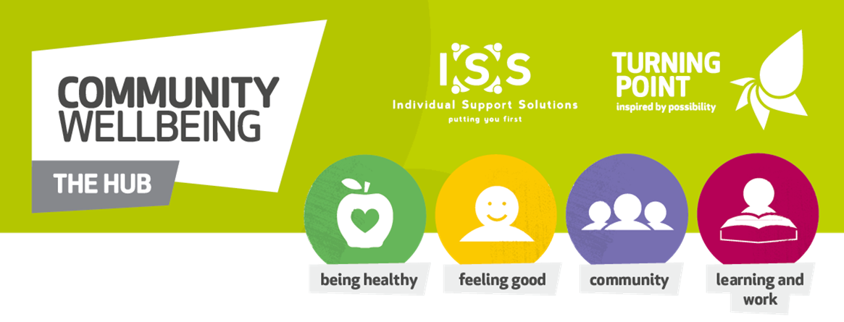

Use of Face Masks
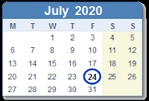 | From Friday 24th July 2020
 | Everybody has to wear to wear a Face Mask in all Shops, Shopping Centres,Take Aways, Public Transport, Hairdressers, Doctors, Dentists and Hospitals
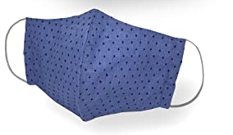  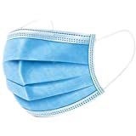 | A Face mask can be a scarf, bandana, religious covering, or a handmade cloth covering, which must fit securely round the side of the face covering your mouth and your nose.
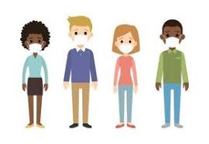 | Everybody has to wear a Face Mask, unless you have a breathing problem, you cannot put it on yourself or it makes you feel very angry or upset. You can print a card for you to use from gov.uk
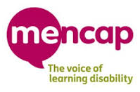 | For more detailed easy read please follow the link for Mencap  https://www.mencap.org.uk/sites/default/files/2020-07/Wearing%20a%20face%20covering%20in%20England%20-%20Updated%20AH-EDIT.pdf

