Annual Health Checks

 | DO you know about all the annual health checks you should be having?
 | Come to the hub to talk to our specialised nurses and learn about these.
 | They can answer and questions you have and support you to get them booked.
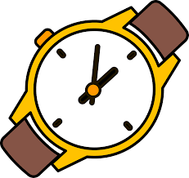  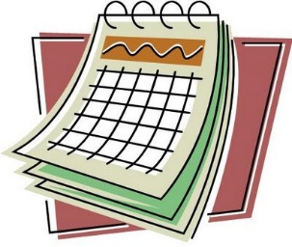 | On Wednesday 24th November  at 11am  at the Nuneaton Hub
If you would like to make an appointment or attend one of our activities contact:
Jade on 07563159070 or
Sherelle on 07874684719
Email - nuneatonhub@isswarks.com or atherstonehub@isswarks.com

