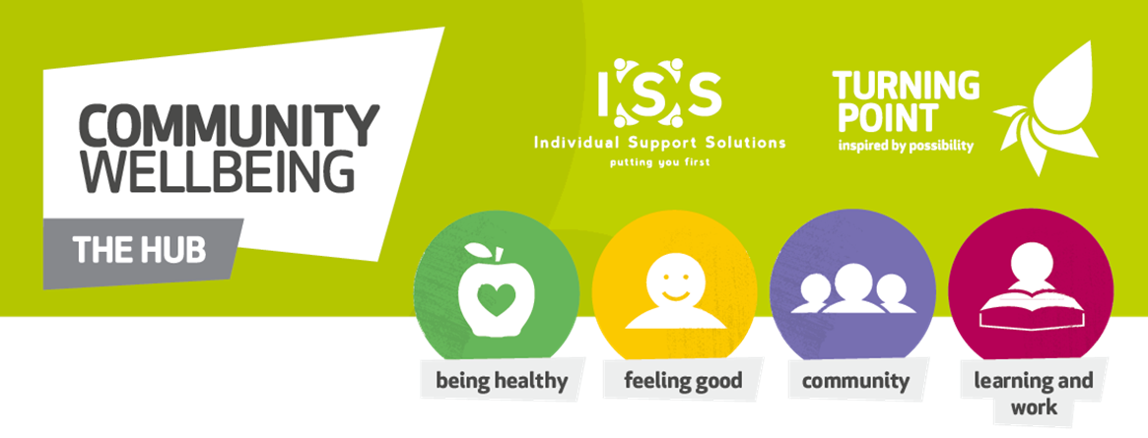

Update from ISS Community Wellbeing Hubs

We have enjoyed meeting with our customers again since we re-opened our hub buildings in July.

We will carry on with 1-1 appointments but we will not be open for drop in customers yet. Please phone or email first if you want to come in and see us.

rugbyhub@isswarks.com
07936 015966

nuneatonhub@isswarks.com
07563 159070

atherstonehub@isswarks.com
07874 684719

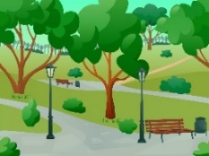  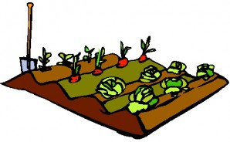 | We have been supporting small groups of customers to meet up safely outdoors and improve their wellbeing by re-connecting with others.
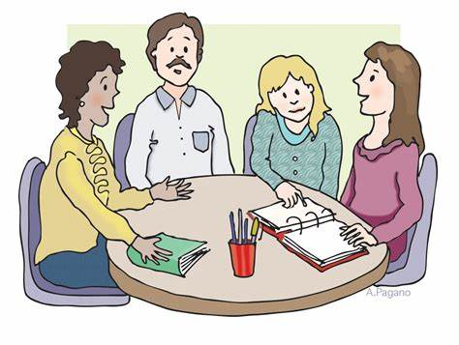  6 | Now it is getting colder, we can start to run some indoor activities. We must only work in groups of 6.

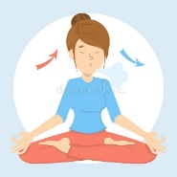
Relaxation Have fun and
connect with IT

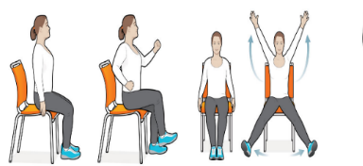
Seated Christmas
exercise crafts

Please contact us if you are interested in any of these activities.

