**Regular groups meeting at North Warwickshire hubs**

|  |  |
| --- | --- |
| See the source image | **Autism Connect Social Group**  Mondays at Nuneaton hub  1:00pm – 3:00pm  A peer led group to build social skills and self-confidence, meet new people and make new friends. Fortnightly sessions. |
| See the source image | **Quiz Evening**  Wednesdays at Atherstone hub  4:30pm to 6:30pm  Come and enjoy an evening of quiz questions, music and socialising! Fortnightly sessions. |
| Image result for allotment clip art | **Allotment**  Come and help out at our Hartshill allotment and learn about growing your own fruit and vegetables.  Fridays 2 – 3pm, spring until autumn  (weather permitting) |
| grapevine | **Grapevine Speaking Up Group**  Have your say on things that matter to you.  Nuneaton – Tuesdays 10am - 12pm  Atherstone - Thursdays 10:30am - 12:30pm  Monthly sessions - dates available in the hubs |

**Activities will also be advertised on the notice boards in the hubs,**

**on our website** [**www.nwcommunityhubs.com**](http://www.nwcommunityhubs.com)

**and our Facebook page search: ‘NW Community Wellbeing Hubs’**

**Visit:** [**https://www.facebook.com/NW-Community-Wellbeing-Hubs-1534756796534359**](https://www.facebook.com/NW-Community-Wellbeing-Hubs-1534756796534359)

**To book a place or to find out more please contact:**

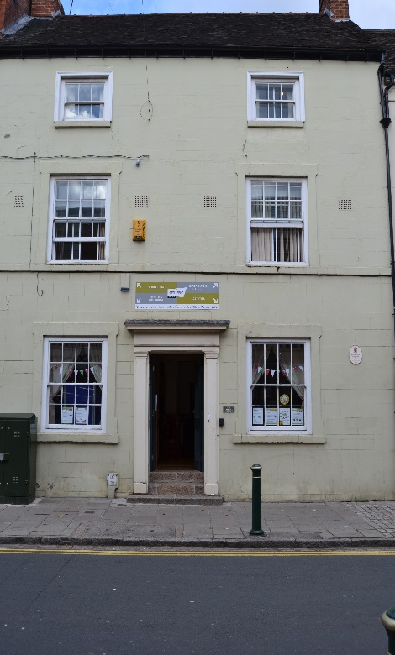

**Atherstone Hub:**

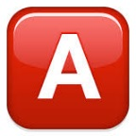 **Claire Ward on 01827 711801**

**or 07874684719**

[Atherstonehub@isswarks.com](mailto:Atherstonehub@isswarks.com)

**106 Long Street, Atherstone, CV9 1AN**

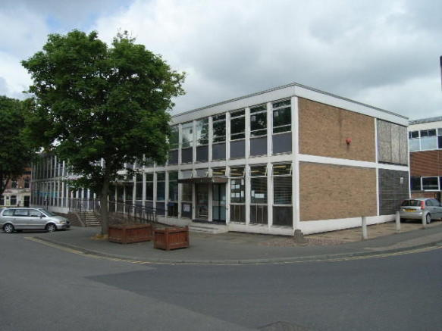 **Nuneaton Hub:**

 **Jade Willis on 07563159070**

[nuneatonhub@isswarks.com](mailto:nuneatonhub@isswarks.com)

**Powell House, Nuneaton, CV11 4DS**

**Please note that we are unable to provide support for individuals accessing the above activities. If you require support to participate or with personal care, please ensure that you are accompanied by a carer or support worker.**

**\*\*Please note the hub charges 50p for drinks per session\*\***

**We look forward to seeing you!**