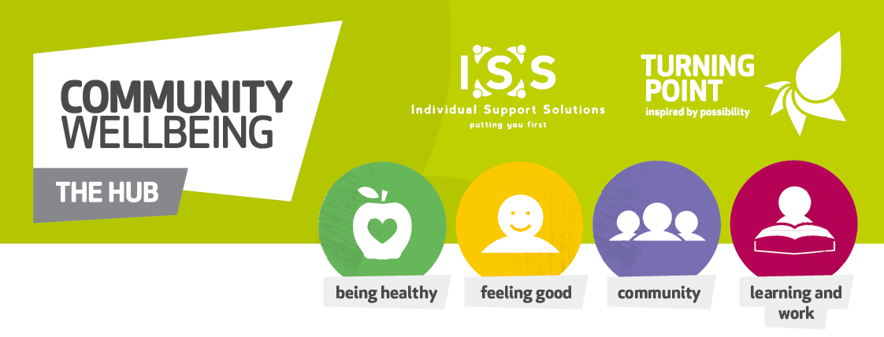

Coming Soon
Rugby Community Wellbeing Hub
&
Rugby Job Centre Plus
Are co-hosting a 6-week Pre-Employment Course
Dates to be confirmed
At
The Benn Partnership Centre
Join us for this Free Course
For more information please contact
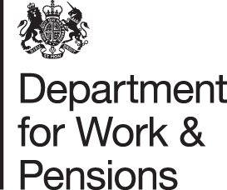
Yvonne on 07936 015966
Or email: rugbyhub@isswarks.com
