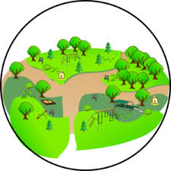
Rugby Community Wellbeing Hub
are hosting Outdoor Activities.
Spaces will be limited for each activity,
if you would be interested in finding out more
Contact Yvonne on 07936 015966
Or
Email: rugbyhub@isswarks.com

